



Accessing LIRICO, oTTAWA pUBLIC lIBRARY’S WEB Catalogue

To access the catalogue from at home
- Access the internet
- Go to our web page (www.library.ottawa.on.ca)
- Click on English
- Click on Lirico Catalogue
- Choose a branch

To access the catalogue from within the library
- Click on the down arrow beside the statement Choose a Branch, or Choose a Bookmobile Stop.



- From the table that appears choose the Branch you wish to consider your home branch.
You will still get to look at items from other branches, but the items in the branch you choose here will appear first and unless you state otherwise, any requests you make will go to the branch you have chosen.
- Then wait for the catalogue to open up.

searching the catalogue

Keyword Search
You will automatically go to the Keyword search page. The default on this page is to do a Title Keyword Search.
  - To change this to a different keyword search click on the down arrow beside the words “Title Keyword”



You will then be faced with the following menu:

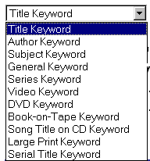

- Move your cursor down this table until you highlight the field you want to search and then left click.
- Next click in the box beside the one described above so that you get a flashing cursor and type your keyword or keywords.
You do not need to use the connector ”and” because the program assumes it. So, for example, you can type anne green and the program will find Anne of Green Gables among many other things. If you only want Anne of Green Gables, you can type in that phrase and under the heading “Match Options”, make sure that you click on the radio button beside the words “Match as a phrase” and even though you will get a lot of hits they will all relate to Anne of Green Gables in some form.
- Click on the GO button
- If when you do your search you retrieve too many items try the “Limit Your Search” options on the bottom of the page.
You can choose format to restrict it to videos, CDs etc. The location box allows you to limit your search to a specific branch and the language option allows you to check only the holdings in the language of your choice.

Browse Search
In some cases you will know the beginning of a title or the last name of an author and then your best bet may be a browse search rather than a keyword search. A browse search gives you an alphabetical or numerical list showing you where what you typed would fit in. For example, let’s say you are looking for the item entitled “Murder a la mode” but could only remember that the title started with murder a la or murder a l’. If you switch to browse search, you can type in murder a l and are immediately presented with the correct item.

If you try a keyword title search, all you can type in is murder a. Even if you search that as a phrase, you will get 79 hits where murder a la mode is number 74.
- Click on the words “Browse Search” in Blue in top right hand corner
- Default is Title Browse. To change it click on the down arrow beside Title Browse to get a drop down menu with other choices
- Click on the type of Browse search you would like to do
- In the box beside the browse search type the title, author, etc. as it would appear on the record eliminating a leading article like the, a, or an for title and inputting the last name first in author browse. (If you are browsing for a title with a leading article and it does not appear, it may be worth redoing it with the leading article in case the coding was incorrect)
- Click on button labeled “GO”
Note that the Browse search only brings you to the alphabetical or numerical list of entries and the search limiters available with Keyword and Advanced Search are not available in Browse.

Advanced Search
Lastly you can do what is called an advanced search. This allows you to construct a Boolean search (i.e. a search where you can use the connectors and, or and not.) Say, for example, you wanted a book and remembered only that it was by Moyes and had murder in its’ title and was published in the early 80’s. You can go to the advanced search and choose to search for a book with murder in it’s title, Moyes in the author keyword field and with a publication date prior to 1988. Your search would look like the one printed below

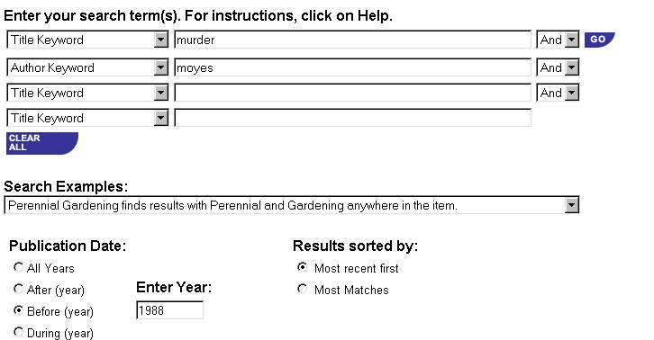
You would then end up with two items one of which was the item you were looking for.

requesting an item

- Find an item in the catalogue using one of the methods described above.
- Click on the title which is in blue and underlined to see the full record.
- Click on the button labeled “Request A Copy”
You will then be presented with information about the item including the branch at which your item can be picked up (this is the same location you chose when you first entered the catalogue). If you wish to change the location click on the down arrow beside the name of the branch to be presented with a menu where you can choose a different branch.
- Click on the white rectangle beside the label “Library Card Number” and type in your entire library card number omitting any spaces.
- Use your tab key to get to the next white rectangle beside the label “PIN”. (If you are using the computers in the library you may have to click on the rectangle instead). Once you have the flashing bar type in your pin number which, if you don’t know it, is usually the last four digits of your phone number.
- Click on the button labeled “Submit Request”
You will receive an acknowledgement of that request as well as information about your place on the hold list. When the item arrives you will be phoned so notify the library if you change your phone number.

accessing your library card

You can use Lirico, our online catalogue, to access the information on your library card. This means you can check on what you have out on your library card, when they are due back, whether you owe the library any money and where you are on the list for items you have requested. You can also renew your books or cancel your requests. To perform any of these functions, you must first access your library card.
- Click on the words “Check My Card” near the top of the screen.
- Fill in the fields for your library card number and your PIN number (remember it requires your full library card number and your PIN number is probably the last four digits of your telephone number.)
- Click on the button labeled “Login”. You will then be presented with some details about your personal information.
Click on the bar beneath ONLY IF THE INFORMATION IS INCORRECT. If you click on it when it is not incorrect your next visit to check out books may take longer. If the information is correct
- Click on one of the group of words in blue on the top of the screen or in blue and underlined below the green line.
CLICK HERE

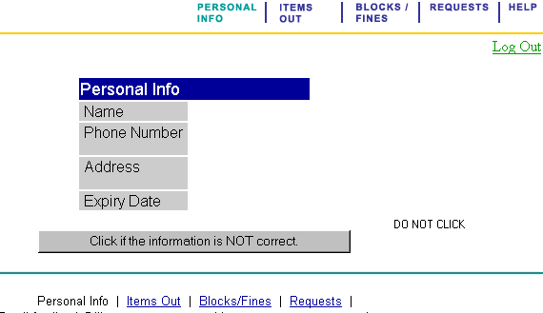
OR CLICK HERE

Renewing Your Library Materials

- Click on the words “Items Out” which are in blue on top of the page or in blue and underlined underneath the green line (see diagram above).
- Select the item(s) you want to renew by clicking in the little box to the left of the title. When you select an item you should see a small checkmark inside the box.
- After you finished choosing the items you want to renew click on the button labeled “Renew Selected” Instead of the small box you will now get a message for each item you asked to renew (i.e. either that the item cannot be renewed or it will say renew ok).

Deleting Library Requests

- Follow the instructions for accessing your card then click on the word Requests in blue on the top of the page or in blue and underlined underneath the green line.
You will then see a list of your requests starting with any that are in the library ready for pickup. For those ready for pickup you will see where it is being held and the date by which you have to pick it up. For those items not yet ready for pickup, you will see the status of the request, your place on the hold list and the expiry date for the hold.
- Click on the small box to the left of the title you want to cancel. You should see a check mark.
- Click on the button on the bottom of the screen labeled “Cancel Selected”. The requests where you have put checkmarks will be deleted.

retrieving other information

- Follow the steps for accessing your card and then click on the words “Blocks/Fines”
- Read notes which include messages about phone notifications, requests not picked up and any money owing on your library card.
- Remember to click on words “Log Out” in green and underlined in top right hand corner to protect your personal information.

